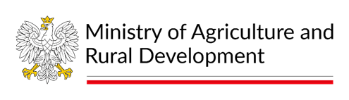

BALTFISH Forum Meeting
5th of September 2023, 12:00 - 17:00 CEST
Ministry of Agriculture and Rural Development, Wspólna 30, Warsaw and online on Teams
Agenda:
1. Opening of the meeting
2. Adoption of the agenda
3. Approval of the minutes from the Forum meeting on 20th June 2023
4. Work program of the Polish BALTFISH Presidency
– Presentation and discussion
5. Commission proposal on fishing opportunities in the Baltic Sea 2024
– Presentation by the European Commission and exchange of views
6. Baltic Sea Advisory Council presentation - work program for the year and the recommendations for the fisheries TAC in 2024.
7. AOB
8. Closure

