From the Swedish Pelagic Federation PO
13.1.21
Technical measures regulation EU 2019/1241, Appendix 8 Part B

Regulation (EU) 2019/1241 of the European Parliament and of the Council of 20 June 2019 on the conservation of fisheries resources and the protection of marine ecosystems through technical measures […]. Annex 8 Baltic Sea, Part B Mesh sizes:

1. Baseline mesh sizes for towed gear

1.1. Without prejudice to the landing obligation, vessels shall use a mesh size of at least 120 mm constructed from T90 or at least 105 mm fitted with a Bacoma exit window of 120 mm.

1.2. Without prejudice to the landing obligation and notwithstanding point 1.1, vessels may use smaller mesh sizes as listed in the following table for the Baltic Sea provided that:
(i) the associated conditions set out in that table are complied with, and by-catches of cod do not exceed 10 % of the total catch in live weight of all marine biological resources landed after each fishing trip; or
(ii) other selectivity modifications are used which have been assessed by STECF upon request of one or more Member States and approved by the Commission. Those selectivity modifications shall result in the same or better selectivity characteristics for cod as that of 120 mm T90, or of 105 mm fitted with a 120 mm Bacoma exit window, respectively
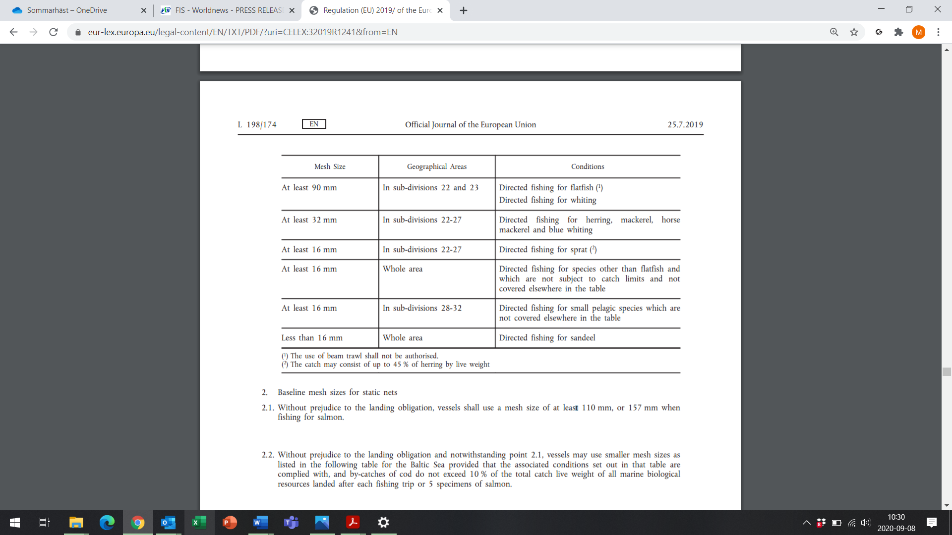

The 32 mm mesh was initially introduced to spare juvenile herring. Today it is scientifically shown that the mortality of fish is equal in the pelagic trawl with 32 mm mesh and 16 mm mesh (codend). The smaller fish die anyway from the damage when passing through the larger mesh size. Scientists agree that the best measure to protect juvenile herring is to protect areas where they gather, but that the 32 mm mesh does not fill this purpose. Therefore, there is no biological reason for the regulation of using 32 mm mesh in the directed fishery for Baltic herring.

Apart from this, the herring in the Baltic is now so small that fishing with 32 mm mesh is not economical. The herrings are simply too small to be caught in 32 mm mesh. Due to the poor catchability of herring in 32 mm mesh, most Swedish fishermen use 16 mm mesh size in the Baltic herring fishery, even if the fishery is targeted for consumption.

When fishing with 16 mm mesh, footnote 2 in the regulation Annex 8, part B states that the catch may consist of up to 45% herring (by live weight) for Baltic subdivision 22-27. The rest of the catch should consist of sprat. For the small-scale coastal fishermen targeting herring for consumption, the quota catch composition that they possess does not match the 45% herring – 55% sprat composition demanded for a 16 mm fishery. Their fishery is more or less made impossible by this regulation. The larger vessels have a greater flexibility in where they fish and may easier find fish to make up the correct catch composition. Despite this, it is a problem even for the larger vessels.

What actions need to be taken to address this problem:
Delete the demand for 32 mm mesh size in the directed fishery for herring, mackerel, horse mackerel and blue whiting. Instead use only minimum 16 mm mesh size. There is no biological ground for 32 mm mesh.

Delete the footnote 2) demanding minimum 55% sprat when fishing with 16 mm mesh

Raise the sprat quota according to the Baltic Sea Multiannual Plan.

