DRAFT Joint Recommendation for mitigation measures to reduce bycatch of the Baltic proper harbour porpoise

Background
Article 3(1) of the Technical Measures Regulation (EU) 2019/1241 (TMR) states that technical measures shall contribute to the objectives of the Common Fisheries Policy set out in the applicable provisions of Article 2 of Regulation (EU) 1380/2013 of 11 December 2013 on the Common Fisheries Policy (CFP) which define as an objective that it shall implement the ecosystem-based approach to fisheries management so as to ensure that negative impacts of fishing activities on the marine ecosystem are minimised, and shall endeavour to ensure that aquaculture and fisheries activities avoid the degradation of the marine environment. Article 3(2)(b) of TMR further defines as an objective the need to contribute to ensure that incidental catches of sensitive marine species, including those listed under Directive 92/43/EEC are minimised and where possible eliminated so that they do not represent a threat to the conservation status of these species. For the purpose of achieving this objective, Member States may cooperate with one another to adopt conservation measures.
The Baltic Proper harbour porpoise (Phocoena phocoena) is listed in Annex II of the Directive 92/43/EEC as animal of Community interest whose conservation requires the designation of special areas of conservation. It is also listed as a sensitive species according to Article 6(8) in the TMR (“sensitive species” is a specie whose conservation status, including its habitat, distribution, population size or population condition is adversely affected by pressures arising from human activities, including fishing activities. Sensitive species, in particular, include species listed in Annexes II and IV to Directive 92/43/EEC, species covered by Directive 2009/147/EC and species whose protection is necessary to achieve good environmental status under Directive 2008/56/EC). Furthermore, the population of the Baltic Proper harbour porpoise has been assessed as “Critically Endangered” by the International Union for Conservation of Nature (IUCN) and the Baltic Marine Environment Protection Commission (HELCOM). All Member States’ assessments and the EU biogeographical assessment of conservation status of the Baltic Proper harbour porpoise in the Baltic Marine biogeographical Region have been assessed as ‘unfavourable-bad’ for the last three consecutive assessments under Article 17 of Directive 92/43/EEC.
The Baltic Proper harbour porpoise is seriously threatened through the risk of a serious harm to the reproductive capacity of this population caused by a population decline estimated below 500 animals in 2020. Article 21(b) of the TMR specifies that a Joint Recommendation (JR) submitted for the purpose of adopting the measures referred to in Article 15(2), in relation to the protection of sensitive species, may in particular specify the use of additional or alternative measures to those referred to in Annex XIII to minimize the incidental catches of the species referred to in Article 11 (marine mammals, seabirds and marine reptiles).
In January 2024 Sweden issued a data call within BALTFISH to all Baltic Member States, asking for the gillnet fisheries effort expressed as days at sea during 2022 for the area containing all ICES squares delimiting the Swedish Exclusive Economic Zone (EEZ), see figure 1. The reported fishing effort was combined with Swedish effort data in order to estimate the total gillnet fishing effort expressed as Days at Sea for 2022. Gillnet fishing was limited in the red sub-area, and also relatively limited during winter months in the green and orange sub-areas. The fishing effort in the yellow area were considered of special significance since gillnet fishing in this area alone corresponded to about 58 percent of the total gillnet fishing effort in all areas during 2022 (see figure 1). The bycatch rate of harbour porpoise in the Baltic Sea was estimated at a workshop on the status of harbour porpoises given by the North Atlantic Marine Mammal Commission and the Norwegian Institute of Marine Research (NAMMCO, 2019). The bycatch rate was calculated by adjusting bycatch rates of porpoises from the Belt Sea population (ICES area 21, 22 and 23) and the density of the Belt Sea population to the Baltic Sea and the density of the Baltic Sea harbour porpoise. If the bycatch rate was related to the density of the harbour porpoise throughout the Central Baltic Sea, this resulted in estimates of bycatch estimates for 2022 ranging between 0.55 – 0.66 individuals yearly for all mesh-sizes.
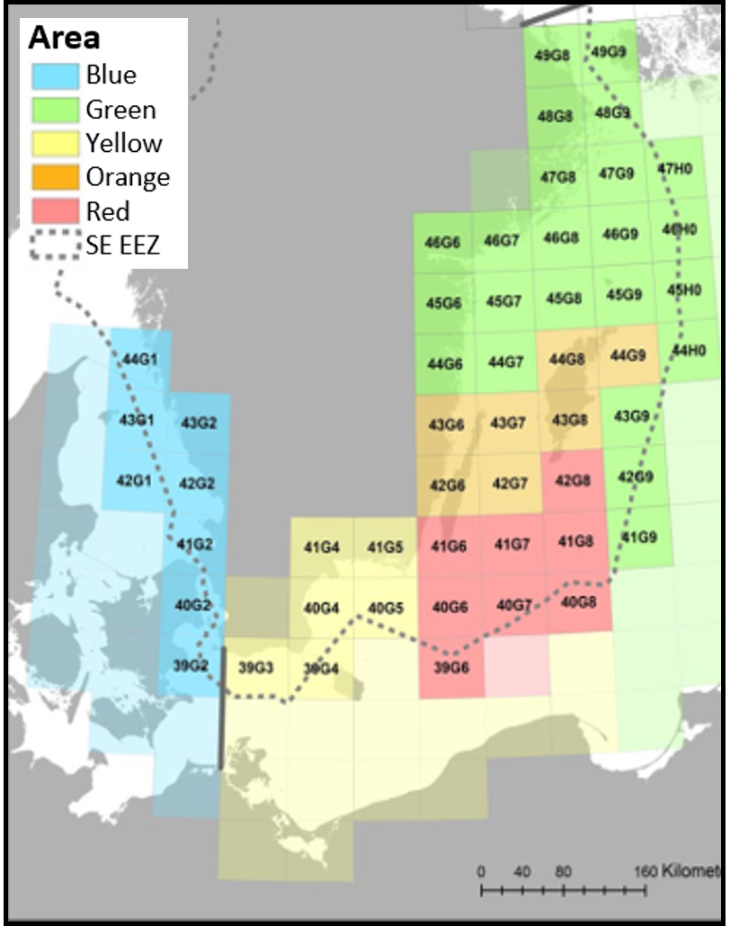
Figure 1. The distribution area of the Baltic Proper harbour porpoise partitioned according to increasing bycatch risk from green, yellow, orange, to red. Numbered Ices squares relates to the bycatch estimations for the Swedish EEZ.
In April 2024 DTU Aqua presented a note to BALTFISH summarizing mitigation methods to reduce bycatch of harbour porpoise (DTU A, 2024). Bycatch can be prevented either by reducing the fishing effort or by decreasing the bycatch per fishing unit effort (BPUE), and the presented mitigation measures were divided into categories of acoustic deterrent devices, spatial-temporal closures, alternative fishing gear, and new mitigation techniques. All presented mitigation measures were also described according to advantages and challenges of each method respectively. The toolbox concluded with general discussion of lessons learned from previous bycatch mitigation implementation schemes.
ICES advice of May 2020 (ICES, 2020a) advises a combination of spatial-temporal closures and application of ADDs/pingers in static nets (trammelnet, gillnet, and semi-driftnet) fisheries for the protection of Baltic Proper harbour porpoise. ICES further advises that protection measures can only be effective when applied for a longer period of time. According to ICES, the threat levels for the Baltic Proper harbour porpoise were considered high for bycatch, contaminants, and three impulsive underwater noise sources.
Three ICES publications were released during 2024, first focussing on effectiveness of dynamic closures and providing an overview of alternative measures to pingers (ICES, 2024a), second describing bycatches of endangered, threatened and protected species (ETP) of marine mammals, seabirds and turtles (ICES, 2024b), and the most relevant advice assessing relative bycatch risk of harbour porpoise in the Baltic Sea based on an analysis of overlap between habitat suitability and fishing effort, which was replaced by the advice provided in March 2025(ICES, 2025). The relevant parts of these publications are further described in section 4.
Based on ICES advice 2020a, 2024a, 2024b and 2025, together with estimates of gillnet fishing effort and available mitigation measures, BALTFISH has prepared a joint recommendation for conservation measures to reduce bycatches of Baltic Proper harbour porpoise and alleviate further risk to this population. The BALTFISH proposal is in addition to the current measures set out in Annex XIII of the TMR.

The Legal Basis
Article 3 in Annex XIII of the TMR states that as a result of scientific evidence, validated by for instance ICES and STECF, of negative impacts of fishing gear on sensitive species, Member States shall submit joint recommendations for additional mitigation measures for the reduction of incidental catches of the concerned areas on the basis of article 15 of this regulation.
Article 15(2) in the TMR specifies that the Commission is empowered to adopt delegated acts in accordance with article 29 of the technical regulation, and to amend, supplement, repeal or derogate form the technical measures set out in Annex XIII. The Commission shall adopt such delegated acts on the basis of a joint recommendation submitted in accordance with Article 18 of Regulation (EU) 1380/2013 and in accordance with the relevant Articles of Chapter 3 of the TMR.
Article 21(b) in the TMR specifies that a joint recommendation submitted for the purpose of adopting the measures referred to in Article 15(2), in relation to the protection of sensitive species, may in particular specify the use of additional or alternative measures to those referred to in Annex XIII to minimize the incidental catches of the species referred to in Article 11 (marine mammals, seabirds and marine reptiles).

BALTFISH
Ministers from the eight Member States (Denmark, Germany, Estonia, Latvia, Lithuania, Poland, Finland and Sweden) in the Baltic Sea Region signed in December 2013 the Memorandum of Understanding (MoU) that sets out the principles and working methods of BALTFISH. The MoU states the aims of BALTFISH with a view to complying with the principles for regionalization as stipulated in Regulation (EU) 1380/2013 and in particular Article 18. Article 18, amongst others, states that Member States having a direct management interest shall cooperate with one another in formulating Joint Recommendations.

The implementing authority
Article 15(2) of the TMR (EU) 2019/1241 specifies that the Commission is empowered to adopt delegated acts in accordance with article 29 of the TMR (EU) 2019/1241, and to amend, supplement, repeal or derogate from the technical measures set out in Annex XIII. The Commission shall adopt such delegated acts on the basis of a JR submitted in accordance with Article 18 of Regulation (EU) 1380/2013 and in accordance with the relevant Articles of Chapter 3 of Regulation (EU) 2019/1241. Furthermore, according to article 18(3) of Regulation (EU) 1380/2013, the Commission may adopt conservation measures by means of delegated or implementing acts based on a Joint Recommendation submitted by the relevant regional cooperation forum, which for the Baltic Sea is the BALTFISH High Level Group.

Consultation with relevant stakeholders
A proposal for a joint recommendation was sent by the BALTFISH Presidency to the Baltic Sea Advisory Council, BSAC, for consultation on [xx xx 20xx]. The BSAC replied to the consultation and informed BALTFISH [xx xx 20xx], regarding the draft JR in a letter to the BALTFISH Presidency dated [xx xx 20xx], and prior to final agreement of BALTFISH HLG and subsequent submission to the Commission of the joint recommendation. [To be updated after the consultation process.]

Existing regulations

The use of acoustic deterrent devices with static nets
The TMR (EU) 2019/1241 laying down in Annex XIII the mitigation measures to reduce incidental catches of sensitive species, and more specifically, in Part A, point 1, establishing the mandatory use of acoustic deterrent devices in certain fisheries, areas and vessels, including part of the Baltic Sea.
The Commission Implementing Regulation (EU) 2020/967 of 3 July 2020 laying down the detailed rules on the signal and implementation characteristics of acoustic deterrent devices as referred to in Part A of Annex XIII of the TMR (EU) 2019/1241.
The Commission Delegated Regulation (EU) 2022/303 of the 15 December 2021 amended Annex XIII of the TMR (EU) 2019/1241. More specifically, Part A, point 3 of the Annex, establishing special measures in certain areas of the Baltic Sea.

Spatial temporal closures
The Commission Delegated Regulation (EU) 2022/303 of the 15 December 2021 amended Annex XIII of the TMR (EU) 2019/1241. More specifically, Part A, point 3 of the Annex, establishing special measures in certain areas of the Baltic Sea.

Scientific background
ICES in its Special Request Advice of 26 May 2020 (ICES, 2020a) has identified seasonal-geographical areas for bycatch mitigation, and referred to the calculated potential biological removal (PBR) bycatch limit as the management objective and identified the high-risk areas for bycatch for the Baltic Proper harbour porpoise. The proposed management area is between line of 13°E as the southwestern border and a line between 60.5°N on the Swedish coast and 61°N on the Finnish coast as the northern border (see figure 2). ASCOBANS Recovery Plan (Jastarnia Plan) for the Baltic Proper harbour porpoises of 2016 shows the high-density areas for harbour porpoises in the Baltic Sea based on the SAMBAH 2016 study (SAMBAH, 2016). It is evident that the occurrence of the harbour porpoise is highest in the southwestern and western waters in the Baltic Sea but rare in the eastern and northern waters (east of longitude 20° E and north of latitude 60° N, Figure 2).
The ASCOBANS resolution from September 2020 on Baltic Proper harbour porpoise urges the Parties to implement swiftly the recommendations on measures for bycatch mitigation made by ICES in areas of more than occasional harbour porpoise occurrence and to put in place long-term bycatch mitigation measures in line with the ICES advice both within and outside marine protected areas in areas of more than occasional harbour porpoise occurrence.
ICES advise of May 2020 (ICES, 2020a) advises a combination of spatial-temporal closures and application of ADDs/pingers in static nets (trammelnet, gillnet, and semi-driftnet) fisheries for the protection of Baltic Proper harbour porpoise.
ICES further advises that protection measures can only be effective when applied for a longer period of time. According to ICES WGMME 2019, the threat levels for the Baltic Proper harbour porpoise were considered high for bycatch, contaminants, and impulsive underwater noise sources such as sonar, pile driving, explosions and seismic surveys The bycatch high-risk fisheries are static nets. Static net fisheries should therefore be regulated with either prohibition to use such gear or to use it only with acoustic deterrent devices. Such restrictions, including restrictions for other gears as appropriate, apply for fishing in the areas which, (according to studies), are areas of concentration of harbour porpoise (SAMBAH, 2016). The ICES advice, however, mentions that there are also concerns about habituation to pingers over time, and a possible reduced foraging efficiency of deterred porpoises. These potential negative consequences of pinger use do not speak in favor of a broad-scale pinger use obligation. ICES also recommends the largescale use of pingers in static net fisheries, regardless of vessel size, addressing the fishing métiers with the highest bycatch rates and affecting a large fraction of static nets. The expected bycatch reduction by this measure will likely have a positive effect on the population, but in areas where porpoises are not abundant and only occasionally observed, the disadvantages of using pingers might exceed the advantages (ICES, 2020b). As the Jastarnia Plan (ASCOBANS, 2016) points out, pingers are only suited as an interim measure until alternative gears are available.
In relation to previous advice on largescale use of pingers (ICES 2020a), ICES has also described alternative measures to pingers to prevent bycatch of the harbour porpoise in the Baltic Sea (ICES, 2024a). The implementation of dynamic closures as a mitigation tool to reduce harbour porpoise bycatch in the Baltic Sea is not considered optimal, since this management tool does not mitigate the interaction between highly mobile elusive species and fisheries with high site dependence. ICES also considers dynamic closures to be particularly problematic in relation to insufficient real time monitoring of harbour porpoise occurrences that could be transmitted to fishers in relevant areas. Finally, ICES concludes that the use of fishing gears with lower bycatch risks (such as traps and pots, longlines, and seines) is the most efficient way of preventing porpoise bycatches (ICES, 2024a).
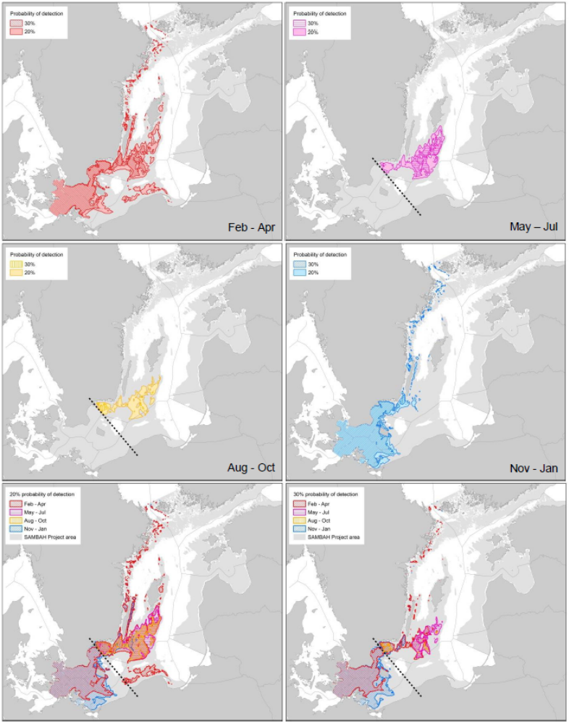 Figure 2. High-density areas for harbour porpoises in the SAMBAH area (shaded) based on predictions of probability of detection. The four upper panels show the high-density areas of two different levels per quarter, and the two lower panels show the full-year pictures for each of the two density levels. During May – October, the isoline of 20% probability of detection encompasses approximately 30% of the Baltic Proper harbour porpoise population, while the isoline of 30% probability of detection encompasses approximately 7.8% of the Baltic Proper harbour porpoise population. During November – April, the same isolines for probability of detection are shown without correlating them to the proportions of the population. Southwest of the SAMBAH population border, the high-density areas are inhabited by animals from both the Baltic and the Belt Sea populations during November – April.
The most recent estimations of annual Baltic harbour porpoise bycatches were summarized in ICES 2024b, however the bycatch estimates for 2023 were presented for both the Baltic proper population and the Belt Sea population combined. The spatial bycatch risk for harbour porpoise in the Baltic Sea was described in ICES special request advice of December 2024 (replaced by new advice in March 2025), in which relative ranks of bycatch risk was mapped for each quarter of the year for ICES rectangles in the Baltic Sea (see figure 3 and ICES, 2025). The relative bycatch risk was determined from the temporal and spatial overlap between estimates of habitat suitability of the harbour porpoise, and fishing effort expressed as number of fishing days. ICES concluded that higher bycatch risk is driven by high harbour porpoise habitat suitability and consistently high fishing effort, specifically for set gillnets with medium and large mesh sizes (ICES, 2025).

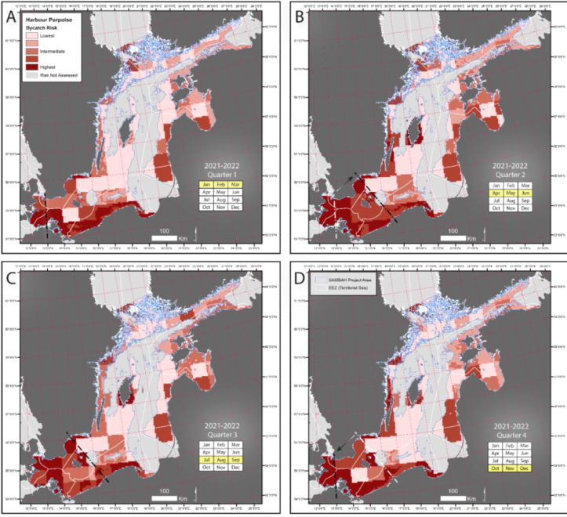
Figure 3. Estimated relative bycatch risk for harbour porpoise in the Baltic Sea at the scale of 5 × 5 km grid cell in set gillnets (GNS) and trammel nets (GTR) for each quarter of pooled years 2021 and 2022. The relative bycatch risk is based on relative ranks and classified using quantiles (20/40/60/80%) of the distribution of values for all four quarters (A-D). Black dotted lines in the southwestern Baltic reflect the approximate position of a management border for Baltic Proper harbour porpoise distribution in summer (panels B and C) and winter (panels A and D), as proposed by Carlén et al. (2018). White dotted lines together with arrows indicate seasonal shifts in this border in the middle of quarter 2 (panel B) and the beginning of quarter 4 (panel D). See ICES, 2025 for details.
The ASCOBANS report of 2016 and Carlén et al., 2018, points out that water depth was found to be a strong predictor for the presence of harbour porpoises, as they are primarily in waters shallower than 40 m, with a tendency to higher densities at 20 – 40 m depth.
The ICES in its advice from May 2020 (ICES, 2020a) did not analyze the filament or twine thicknesses used in static nets in the Baltic Sea, thereof it is necessary to take into consideration FAO relevant reports. FAO Report (FAO, 2018) shows that gillnets constructed from weaker twines might facilitate the release of entangled cetaceans. In North Sea and West of Scotland gillnet fishery thinner twine monofilament nets (0,4 mm, 90 mm mesh size) reduced bycatch of harbour porpoise when compared to thick (0.6 mm twine diameter, 267 mm mesh size) monofilament nets. Marine mammals should be better able to break free from thinner twined gillnets, but uncertainty remains regarding their health and survival following the encounter (i.e., unaccounted for mortality).
In the eastern and northern part of the Baltic Sea mostly thin twines (0,1-0,45 mm) are used in coastal gillnets fisheries due to the smaller fish targeted (i.e. perch, herring, smelt, whitefish, garfish, flatfish, pikeperch, vimba, roach, ide) and mostly shallower (less than 20 m depth) water where no strong currents occur. After the closure of eastern cod target fishery in 2019 the use of 2-4 mm twine gillnets has decreased remarkably in the Baltic Sea.

BALTFISH recommendations on bycatch mitigation measures for Baltic Proper harbour porpoise

Definitions
- Static nets mean any type of gillnet, entangling net or trammel net that is anchored to the seabed for fish to swim into and become entangled or enmeshed in the netting, as defined in article 6(23) in Regulation (EU) 2019/1241 of the European Parliament and of the Council.
- Mesh size according to article 6(34) in Regulation (EU) 2019/1241 of the European Parliament and of the Council.

The BALTFISH HLG recommends the following conservation measures for union fishing vessels:
- The use of static nets with a net height above 4 metres is prohibited for all nets with mesh sizes larger than 120 millimetres, within the geographical areas specified below.

Geographical areas:

- Subdivision 24, and the Swedish Exclusive Economic Zone (EEZ) of subdivisions 25, 27, and 28.2 (see figure 4).
Exempted geographical areas in subdivision 24:
The measure under point 1 does not apply in “Achterwasser” and “Stettiner Haff” within the baseline, specifically south of the line between 54° 10,31' N, 13° 42,0 ' E and 54° 10,31' N 13° 46,4 ' E (“Grenze Peenestrom”) (see figure 5).

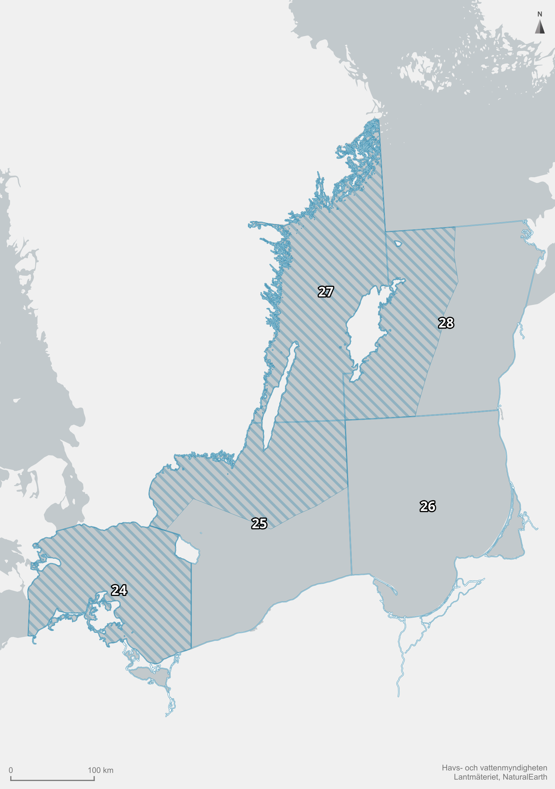
Figure 4. Map of geographical areas.

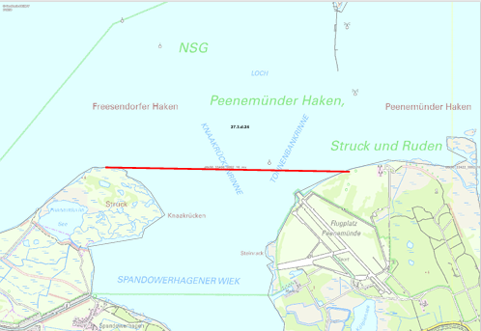

Figure 5. Map of Achterwasser.and Stettiner Haff.

[Placeholder to include drafting concerning the monitoring of this measure and regular reporting within Baltifsh.]

References
ASCOBANS, 2016. ASCOBANS Recovery Plan for Baltic Harbour Porpoises: Jastarnia Plan (2016 Revision). Agreement on the Conservation of Small Cetaceans in the Baltic, North East Atlantic, Irish and North Seas.
ASCOBANS, 2020. Resolution 9.2, The Baltic Proper Harbour Porpoise, 23 September 2020.
Carlén I, Thomas L, Carlström J, Amundin M, Teilmann J, Tregenza N, Tougaard J, Koblitz JC, Sveegaard S, Wennerberg Det al. (2018) Basin-scale distribution of harbour porpoises in the Baltic Sea provides basis for effective conservation actions. Biol. Conserv. 226: 42–53. https://doi.org/10.1016/j.biocon.2018.06.031
DTU A, 2024. Mitigation methods to reduce bycatch of harbour porpoises (Phocoena phocoena). Note to BALTFISH, 14 march 2024.
FAO, 2018. Report of the expert workshop on means and methods for reducing marine mammal mortality in fishing and aquaculture operations, Rome, 20-23 March 2018.
ICES. 2019. Working Group on Marine Mammal Ecology (WGMME). ICES Scientific Reports. 1:22. 131 pp. http://doi.org/10.17895/ices.pub.4980
ICES, 2020a. Special Request Advice of 26 May 2020 on EU request on emergency measures to prevent bycatch of common dolphin (Delphinus delphis) and Baltic Proper harbour porpoise (Phocoena phocoena) in the Northeast Atlantic.
ICES, 2020b. Report on workshop on Fisheries emergency measures to minimise bycatch of shortbeaked common dolphins in the bay of Biskay and harbour porpoise in the Baltic Sea.
ICES, 2024a. EU request on alternative measures to prevent bycatch of the harbour porpoise (Phocoena phocoena) in the Baltic Sea. In Report of the ICES Advisory Committee, 2024. ICES Advice 2024, sr.2024.12. https://doi.org/10.17895/ices.advice.26868907
ICES, 2024b. Bycatch of endangered, threatened and protected species of marine mammals, seabirds and marine turtles, and selected fish species of bycatch relevance. In Report of the ICES Advisory Committee, 2024. ICES Advice 2024, byc.eu. https://doi.org/10.17895/ices.advice.27999401
ICES, 2025.Support for the implementation of the Action Plan for Harbour porpoise in the Baltic Sea (Baltic Proper). Replacing advice provided in December 2024. In report of the ICES Advisory Committee, 2025. ICES advice2025, sr.2024.20. https://doi.org/10.17895/ices.advice.28616360
NAMMCO, 2019. North Atlantic Marine Mammal Commission and the Norwegian Institute of Marine Research. Report of Joint IMR. In NAMMCO International Workshop on the Status of Harbour Porpoises in the North Atlantic. Tromsø, Norway.
SAMBAH, 2016. Final report for LIFE+ project SAMBAH LIFE08 NAT/S/000261 covering the project activities from 01/01/2010 to 30/09/2015. Reporting date 29/02/2016.

